**(6428317 Mukesh P)**

***WEEK 3***

**Hands on 1**

**Spring Data JPA - Quick Example**

Resources:

Application.properties:

logging.level.org.springframework=info

logging.level.com.cognizant=debug

logging.level.org.hibernate.SQL=trace

logging.level.org.hibernate.type.descriptor.sql=trace

logging.pattern.console=%d{dd-MM-yy} %d{HH:mm:ss.SSS} %-20.20thread %5p %-25.25logger**{25}** %25M %4L %m%n

spring.datasource.driver-class-name=com.mysql.cj.jdbc.Driver

spring.datasource.url=jdbc:mysql://localhost:3306/ormlearn

spring.datasource.username=root

spring.datasource.password=oreo

spring.jpa.hibernate.ddl-auto=validate

spring.jpa.properties.hibernate.dialect=org.hibernate.dialect.MySQLDialect

Country.java:

**package** com.cognizant.orm_learn.model;

**import** jakarta.persistence.*;

@Entity

@Table(name = "country")

**public** **class** Country {

@Id

@Column(name = "code")

**private** String code;

@Column(name = "name")

**private** String name;

**public** String getCode() { **return** code; }

**public** **void** setCode(String code) { **this**.code = code; }

**public** String getName() { **return** name; }

**public** **void** setName(String name) { **this**.name = name; }

@Override

**public** String toString() {

**return** "Country [code=" + code + ", name=" + name + "]";

}

}

CountryRepoistory.java:

**package** com.cognizant.orm_learn.repository;

**import** org.springframework.data.jpa.repository.JpaRepository;

**import** org.springframework.stereotype.Repository;

**import** com.cognizant.orm_learn.model.Country;

@Repository

**public** **interface** CountryRepository **extends** JpaRepository<Country, String> {

}

CountryService.java:

**package** com.cognizant.orm_learn.service;

**import** java.util.List;

**import** org.springframework.beans.factory.annotation.Autowired;

**import** org.springframework.stereotype.Service;

**import** org.springframework.transaction.annotation.Transactional;

**import** com.cognizant.orm_learn.model.Country;

**import** com.cognizant.orm_learn.repository.CountryRepository;

@Service

**public** **class** CountryService {

@Autowired

**private** CountryRepository countryRepository;

@Transactional

**public** List<Country> getAllCountries() {

**return** countryRepository.findAll();

}

}

OrmLearnApplication.java:

**package** com.cognizant.orm_learn;

**import** java.util.List;

**import** org.slf4j.Logger;

**import** org.slf4j.LoggerFactory;

**import** org.springframework.boot.SpringApplication;

**import** org.springframework.boot.autoconfigure.SpringBootApplication;

**import** org.springframework.context.ApplicationContext;

**import** com.cognizant.orm_learn.model.Country;

**import** com.cognizant.orm_learn.service.CountryService;

@SpringBootApplication

**public** **class** OrmLearnApplication {

**private** **static** **final** Logger ***LOGGER*** = LoggerFactory.*getLogger*(OrmLearnApplication.**class**);

**private** **static** CountryService *countryService*;

**public** **static** **void** main(String[] args) {

ApplicationContext context = SpringApplication.*run*(OrmLearnApplication.**class**, args);

***LOGGER***.info("Inside main");

*countryService* = context.getBean(CountryService.**class**);

*testGetAllCountries*();

}

**private** **static** **void** testGetAllCountries() {

***LOGGER***.info("Start");

List<Country> countries = *countryService*.getAllCountries();

***LOGGER***.debug("countries={}", countries);

***LOGGER***.info("End");

}

}

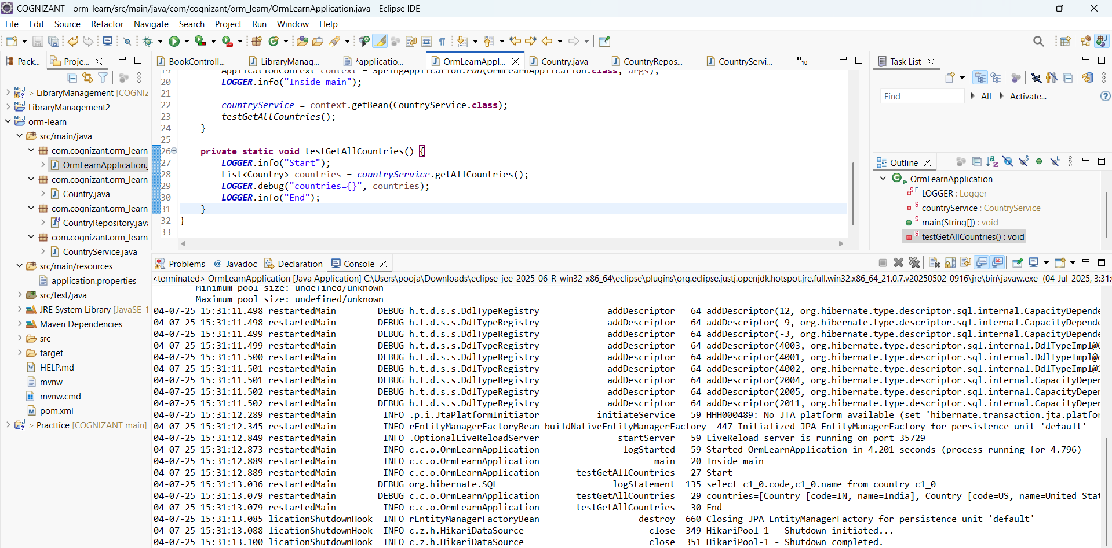

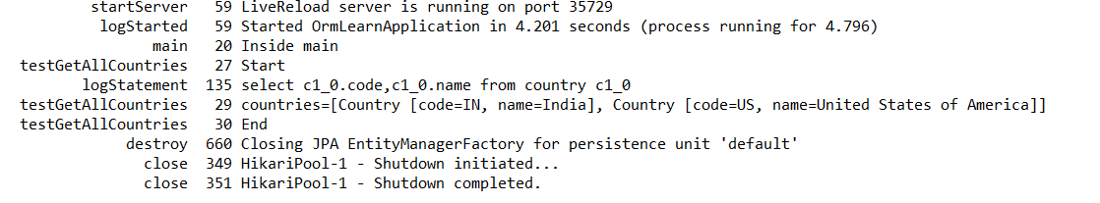

**Hands on 4**

**Difference between JPA, Hibernate and Spring Data JPA**

This is a study exercise of the difference between JPA,Hibernate and Spring Data JPA,

**Hibernate Code Will be :**

public Integer addEmployee(Employee employee){

Session session = factory.openSession();

Transaction tx = null;

Integer employeeID = null;

try {

tx = session.beginTransaction();

employeeID = (Integer) session.save(employee);

tx.commit();

} catch (HibernateException e) {

if (tx != null) tx.rollback();

e.printStackTrace();

} finally {

session.close();

}

return employeeID;

}

This is **Spring Data JPA Code**

CountryService.java:

@Autowired

private CountryRepository countryRepository;

@Transactional

public void addCountry(Country country) {

countryRepository.save(country);

}

CountryRepository.java:

public interface CountryRepository extends JpaRepository<Country, String> {

}

Main.java:

**package** com.cognizant.orm_learn;

**import** java.util.List;

**import** org.slf4j.Logger;

**import** org.slf4j.LoggerFactory;

**import** org.springframework.boot.SpringApplication;

**import** org.springframework.boot.autoconfigure.SpringBootApplication;

**import** org.springframework.context.ApplicationContext;

**import** com.cognizant.orm_learn.model.Country;

**import** com.cognizant.orm_learn.service.CountryService;

@SpringBootApplication

**public** **class** OrmLearnApplication {

**private** **static** **final** Logger ***LOGGER*** = LoggerFactory.*getLogger*(OrmLearnApplication.**class**);

**private** **static** CountryService *countryService*;

**public** **static** **void** main(String[] args) {

ApplicationContext context = SpringApplication.*run*(OrmLearnApplication.**class**, args);

***LOGGER***.info("Inside main");

*countryService* = context.getBean(CountryService.**class**);

*testAddCountry*();

*testGetAllCountries*();

}

**private** **static** **void** testAddCountry() {

***LOGGER***.info("Start addCountry");

Country newCountry = **new** Country();

newCountry.setCode("JP");

newCountry.setName("Japan");

*countryService*.addCountry(newCountry);

***LOGGER***.info("End addCountry");

}

**private** **static** **void** testGetAllCountries() {

***LOGGER***.info("Start");

List<Country> countries = *countryService*.getAllCountries();

***LOGGER***.debug("countries={}", countries);

***LOGGER***.info("End");

}

}

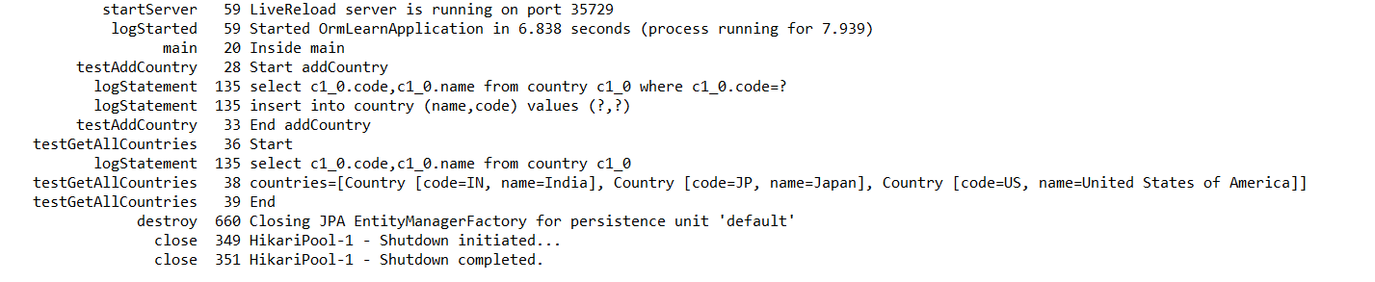

**ADDITIONAL HANDS-ON:**

**Hands on 5**

**Implement services for managing Country**   
  
CountryService.java:

**package** com.cognizant.orm_learn.service;

**import** java.util.List;

**import** java.util.Optional;

**import** org.springframework.beans.factory.annotation.Autowired;

**import** org.springframework.stereotype.Service;

**import** org.springframework.transaction.annotation.Transactional;

**import** com.cognizant.orm_learn.model.Country;

**import** com.cognizant.orm_learn.repository.CountryRepository;

@Service

**public** **class** CountryService {

@Autowired

**private** CountryRepository countryRepository;

**public** Country findCountryByCode(String code) {

Optional<Country> result = countryRepository.findById(code);

**return** result.orElse(**null**);

}

@Transactional

**public** **void** addCountry(Country country) {

countryRepository.save(country);

}

@Transactional

**public** **void** updateCountry(String code, String name) {

Country country = findCountryByCode(code);

**if** (country != **null**) {

country.setName(name);

countryRepository.save(country);

}

}

@Transactional

**public** **void** deleteCountry(String code) {

countryRepository.deleteById(code);

}

@Transactional

**public** List<Country> findCountriesByPartialName(String partialName) {

**return** countryRepository.findByNameContainingIgnoreCase(partialName);

}

}

**CountryServiceTest.java:**

**package** com.cognizant.orm_learn;

**import** java.util.*;

**import** org.springframework.beans.factory.annotation.Autowired;

**import** org.springframework.boot.CommandLineRunner;

**import** org.springframework.stereotype.Component;

**import** com.cognizant.orm_learn.model.Country;

**import** com.cognizant.orm_learn.service.CountryService;

@Component

**public** **class** CountryServiceTest **implements** CommandLineRunner {

@Autowired

**private** CountryService countryService;

@Override

**public** **void** run(String... args) **throws** Exception {

System.***out***.println("Finding country with code 'IN':");

System.***out***.println(countryService.findCountryByCode("IN"));

System.***out***.println("\nAdding new country 'JP - Japan'");

Country newCountry = **new** Country();

newCountry.setCode("JP");

newCountry.setName("Japan");

countryService.addCountry(newCountry);

System.***out***.println("\nUpdating country name 'JP' to 'Japan Updated'");

countryService.updateCountry("JP", "Japan Updated");

System.***out***.println("\nSearching countries with partial name 'land'");

List<Country> countries = countryService.findCountriesByPartialName("land");

System.***out***.println("Found " + countries.size() + " countries:");

countries.forEach(System.***out***::println);

System.***out***.println("\nDeleting country with code 'JP'");

countryService.deleteCountry("JP");

System.***out***.println("\nVerifying delete:");

System.***out***.println(countryService.findCountryByCode("JP"));

}

}

**ApplicationProperties.java:**

logging.level.org.springframework=info

logging.level.com.cognizant=debug

logging.level.org.hibernate.SQL=trace

logging.level.org.hibernate.type.descriptor.sql=trace

logging.pattern.console=%d{dd-MM-yy} %d{HH:mm:ss.SSS} %-20.20thread %5p %-25.25logger**{25}** %25M %4L %m%n

spring.datasource.driver-class-name=com.mysql.cj.jdbc.Driver

spring.datasource.url=jdbc:mysql://localhost:3306/ormlearn

spring.datasource.username=root

spring.datasource.password=oreo

spring.jpa.show-sql=true

spring.jpa.hibernate.ddl-auto=update

spring.jpa.properties.hibernate.dialect=org.hibernate.dialect.MySQLDialect

